

**naïve bayes and decision tree analysis (ASSESSMENT - 2)**

**CSE4020(MACHINE LEARNING)LAB:L49-L50**



**FEBURARY 11, 2022**

**ANIRUDH VADERA**

**20BCE2940**

**QUESTION:**

1. **Naïve Bayes Classification:**

Classify the mail as spam or not using Naïve Bayes classifier. Hard code it to learn the model.

**Expected Output**

**-----------------------**

1. **Likelihood probabilities**
2. **confusion matrix**
3. **accuracy**
4. **Precision, Recall**

**DATASET:** <https://www.kaggle.com/balaka18/email-spam-classification-dataset-csv>

1. **Decision Tree**

Classify the fruit by its type based on the fruit_name, fruit_subtype, mass, width, height, and color_score. Construct CART tree. If possible prune it.

**Expected Output**

**-----------------------**

1. **Decision tree without pruning**
2. **Decision tree after pruning**
3. **Confusion matrix**
4. **Accuracy, precision, recall**

**DATASET:** <https://www.kaggle.com/mjamilmoughal/fruits-with-colors-dataset>

* **Naïve Bayes**

**Description:**

* Naïve Bayes algorithm is a supervised learning algorithm, which is based on **Bayes theorem** and used for solving classification problems.
* It is mainly used in *text classification* that includes a high-dimensional training dataset.
* Naïve Bayes Classifier is one of the simple and most effective Classification algorithms which helps in building the fast machine learning models that can make quick predictions.
* **It is a probabilistic classifier, which means it predicts on the basis of the probability of an object**.

## **Bayes' Theorem:**

* Bayes' theorem is also known as **Bayes' Rule** or **Bayes' law**, which is used to determine the probability of a hypothesis with prior knowledge. It depends on the conditional probability.
* The formula for Bayes' theorem is given as:

Naïve Bayes Classifier Algorithm

**Where,**

* **P(A|B) is Posterior probability**: Probability of hypothesis A on the observed event B.
* **P(B|A) is Likelihood probability**: Probability of the evidence given that the probability of a hypothesis is true.
* **P(A) is Prior Probability**: Probability of hypothesis before observing the evidence.
* **P(B) is Marginal Probability**: Probability of Evidence.

**Multinomial**: The Multinomial Naïve Bayes classifier is used when the data is multinomial distributed. It is primarily used for document classification problems, it means a particular document belongs to which category such as Sports, Politics, education, etc.  
The classifier uses the frequency of words for the predictors.

**Formula Used:**

Naive Bayes algorithm will make the classification based on the results it gets to these two equations below, where "w1" is the first word, and w1,w2, ..., wn is the entire message:

Equation

Equation

If P(Spam | w1,w2, ..., wn) is greater than P(Ham | w1,w2, ..., wn), then the message is spam.

To calculate P(wi|Spam) and P(wi|Ham), we need to use separate equations:

Equation

Equation

Equation

Equation

Equation

Equation

Equation

Equation

**Code:**

import matplotlib.pyplot as plt

import pandas as pd

from sklearn.model_selection import train_test_split

from sklearn.metrics import confusion_matrix, accuracy_score, precision_score, recall_score,classification_report

import seaborn as sns

**# Importing the dataset**

df=pd.read_csv("C:/Users/Anirudh/OneDrive/Desktop/emails.csv")

print("The dataset is as following : [5172 rows x 3002 columns]")

print(df)

print("\n")

**# 0 - Non Spam**

**# 1 - Spam**

df['Prediction'].value_counts(normalize=True)

**# Check for missing values**

print("Checking for missing values :")

print(df.isnull().sum())

print("\n")

**# Printing the header of the dataset**

print("Dataset Header : ")

print(df.head())

print("\n")

df_train, df_test = train_test_split(df,test_size=0.009,train_size=0.991,random_state=0)

**# Isolating spam and ham messages first**

spam_messages = df_train[df_train['Prediction'] == 1]

ham_messages = df_train[df_train['Prediction'] == 0]

**# P(Spam) and P(Ham)**

p_spam = len(spam_messages) / len(df_train)

p_ham = len(ham_messages) / len(df_train)

df_train_n_of_count_spam = spam_messages.iloc[:,1:-1]

df_train_n_of_count_ham = ham_messages.iloc[:,1:-1]

spam_messages['No_of_words']= df_train_n_of_count_spam.sum(axis=1)

ham_messages['No_of_words']= df_train_n_of_count_ham.sum(axis=1)

**# N_Spam**

n_spam = spam_messages['No_of_words'].sum()

**# N_Ham**

n_ham = ham_messages['No_of_words'].sum()

**# N_Vocabulary**

n_vocabulary = len(df_train.columns) - 2

**# Laplace smoothing**

alpha = 1

**# Initiate parameters**

parameters_spam = {unique_word:0 for unique_word in df_train.columns[1:-1]}

parameters_ham = {unique_word:0 for unique_word in df_train.columns[1:-1]}

**# Calculate parameters**

for word in df_train.columns[1:-1]:

n_word_given_spam = spam_messages[word].sum() # spam_messages already defined

p_word_given_spam = (n_word_given_spam + alpha) / (n_spam + alpha*n_vocabulary)

parameters_spam[word] = p_word_given_spam

n_word_given_ham = ham_messages[word].sum() # ham_messages already defined

p_word_given_ham = (n_word_given_ham + alpha) / (n_ham + alpha*n_vocabulary)

parameters_ham[word] = p_word_given_ham

def classify(message):

p_spam_given_message = p_spam

p_ham_given_message = p_ham

for word in message:

if word in parameters_spam:

p_spam_given_message *= parameters_spam[word]

if word in parameters_ham:

p_ham_given_message *= parameters_ham[word]

if p_ham_given_message > p_spam_given_message:

return 0

elif p_ham_given_message < p_spam_given_message:

return 1

else:

return 0

message_list_to_predict = []

Y_pred = []

itr = 0

while(itr<len(df_test)):

message_list_to_predict = []

columns = df_test.columns[1:-1]

for column in columns:

temp = df_test.iloc[itr,:][column]

for i in range(temp):

message_list_to_predict.append(column)

Y_pred.append(classify(message_list_to_predict))

itr = itr + 1

Y_test = df_test.iloc[:,-1]

**# Checking the accuracy of our model**

print('Accuracy: ',accuracy_score(Y_test,Y_pred))

print('Precision: %.3f' % precision_score(Y_test, Y_pred))

print('Recall: %.3f' % recall_score(Y_test, Y_pred))

**# Our Model Report**

print('*************** Evaluation on Our Model ***************')

print('Accuracy Score: ', accuracy_score(Y_test,Y_pred))

# Look at classification report to evaluate the model

print(classification_report(Y_test, Y_pred))

print('--------------------------------------------------------')

print("")

**# Confusion Matrix**

cm = confusion_matrix(Y_test, Y_pred)

print(cm)

plt.figure(figsize=(5,5))

sns.heatmap(data=cm,linewidths=.5, annot=True,square = True, cmap = 'Blues')

plt.ylabel('Actual label')

plt.xlabel('Predicted label')

all_sample_title = "(Predicted and Actual Y_values)"

plt.title(all_sample_title, size = 15)

**# likelihood Probabilities**

print(parameters_spam)

print(parameters_ham)

**Code Snippets:**

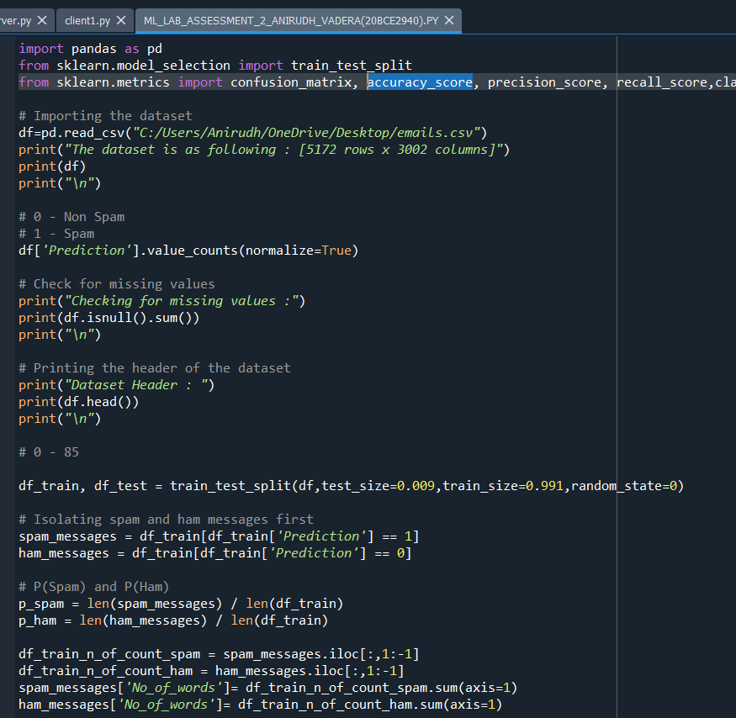

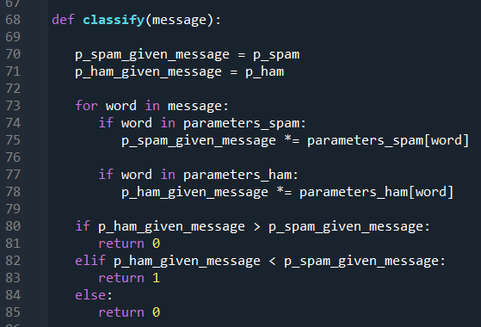

**Output and Results:**

**Dataset Details:**

**Dataset:**

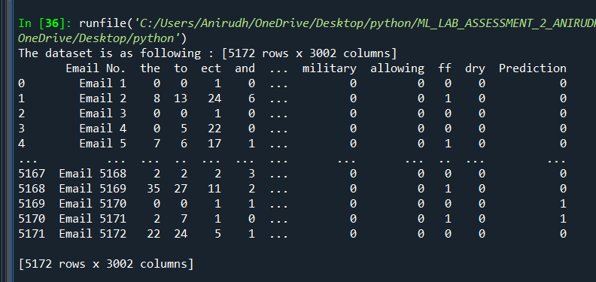

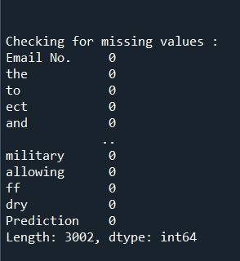

**As the missing values is none we can proceed further:**

**Dataset Details:**

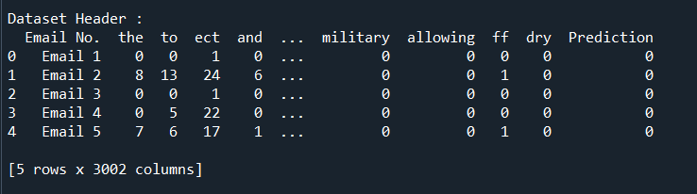

**Probabilities and calculating constants:**

**Calculating P(Spam) and P(Ham) i.e probability of spam and non-spam messages in dataset**

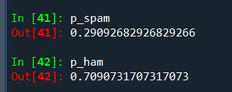

**Likelihood Probability:**

**The whole Formula:**

Equation

Equation

**The required Likelihood Probability:**

Equation

Equation

**These are calculated for every word that exists in our dataset:**

**The 2 of such word probabilities are:**

**For spam:**

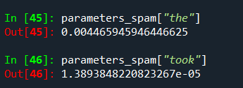

**For ham:**

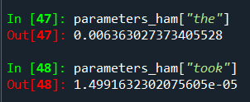

**Showing all such likelihood probabilities for spam as well as non-spam:**

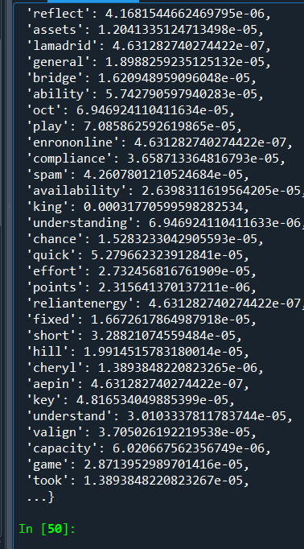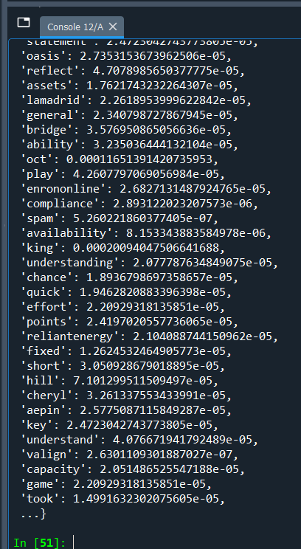**For spam: For ham:**

**As there are around 3000 probabilities they can’t be set in single screen.**

**Confusion Matrix:**

**C:\Users\Anirudh\OneDrive\Pictures\Screenshots\Screenshot (2994).pngHere 0 = Non-Spam**

**And 1 = Spam**

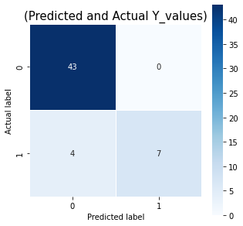

**We get to know out 43 predictions were correct for non-spam and 7 predictions were correct for spam**

**Accuracy Analysis(Errors):**

**C:\Users\Anirudh\OneDrive\Pictures\Screenshots\Screenshot (2996).png**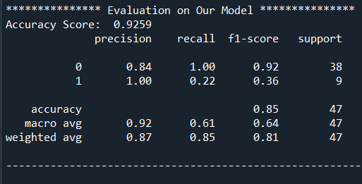

**Inference:**

* **From confusion matrix we get to know our model predicted 43 correct non spam emails and 7 correct spam emails whereas it predicted 4 spam emails as non-spam**
* **The accuracy of our model is 92.25 percent whereas precision is 100 percent and recall is 22.2 percent.**
* **The dataset was very large so we took the test dataset as only a small fraction of the dataset due to a huge training set our accuracy was above par.**
* **Decision Tree**

**Description:**

* Decision Tree is a **Supervised learning technique**that can be used for both classification and Regression problems, but mostly it is preferred for solving Classification problems. It is a tree-structured classifier, where**internal nodes represent the features of a dataset, branches represent the decision rules** and **each leaf node represents the outcome.**
* In a Decision tree, there are two nodes, which are the **Decision Node** and**Leaf Node.** Decision nodes are used to make any decision and have multiple branches, whereas Leaf nodes are the output of those decisions and do not contain any further branches.
* The decisions or the test are performed on the basis of features of the given dataset.
* ***It is a graphical representation for getting all the possible solutions to a problem/decision based on given conditions.***
* It is called a decision tree because, similar to a tree, it starts with the root node, which expands on further branches and constructs a tree-like structure.
* In order to build a tree, we use the **CART algorithm,** which stands for **Classification and Regression Tree algorithm.**
* A decision tree simply asks a question, and based on the answer (Yes/No), it further split the tree into subtrees.
* Below diagram explains the general structure of a decision tree:

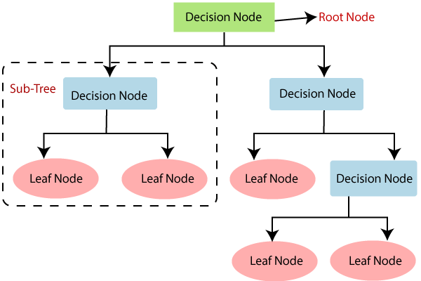

**Formula Used:**

**Information Gain:**

* Information gain is the measurement of changes in entropy after the segmentation of a dataset based on an attribute.
* It calculates how much information a feature provides us about a class.
* According to the value of information gain, we split the node and build the decision tree.
* A decision tree algorithm always tries to maximize the value of information gain, and a node/attribute having the highest information gain is split first. It can be calculated using the below formula:

Information Gain= Entropy(S)- [(Weighted Avg) *Entropy(each feature)

**Entropy:** Entropy is a metric to measure the impurity in a given attribute. It specifies randomness in data. Entropy can be calculated as:

Entropy(s)= -P(yes)log2 P(yes)- P(no) log2 P(no)

**Where,**

* **S= Total number of samples**
* **P(yes)= probability of yes**
* **P(no)= probability of no**

### Gini Index:

* Gini index is a measure of impurity or purity used while creating a decision tree in the CART(Classification and Regression Tree) algorithm.
* An attribute with the low Gini index should be preferred as compared to the high Gini index.
* It only creates binary splits, and the CART algorithm uses the Gini index to create binary splits.
* Gini index can be calculated using the below formula:

Gini Index= 1- ∑jPj2

## **Pruning:**

Pruning is a process of deleting the unnecessary nodes from a tree in order to get the optimal decision tree.

A too-large tree increases the risk of overfitting, and a small tree may not capture all the important features of the dataset. Therefore, a technique that decreases the size of the learning tree without reducing accuracy is known as Pruning. There are mainly two types of tree **pruning**technology used:

* **Cost Complexity Pruning**
* **Reduced Error Pruning.**

**Code:**

import matplotlib.pyplot as plt

import pandas as pd

from sklearn.model_selection import train_test_split

from sklearn.tree import DecisionTreeClassifier

from sklearn import tree

from sklearn.metrics import plot_confusion_matrix, confusion_matrix, accuracy_score, precision_score, recall_score,classification_report

import seaborn as sns

df = pd.read_table("C:/Users/Anirudh/OneDrive/Desktop/fruit_data_with_colors.txt")

df = pd.DataFrame(df)

print("The dataset is as following :")

print(df)

print("\n")

**# Check for missing values**

print("Checking for missing values :")

print(df.isnull().sum())

print("\n")

**# Printing the header of the dataset**

print("Dataset Header : ")

print(df.head())

print("\n")

**# Information regarding the columns**

print("Information regarding the columns : ")

print(df.info())

print("\n")

**# Information related to the dataset**

print("Dataset Details : ")

print(df.describe())

print("\n")

**# correlation matrix**

sns.heatmap(df.corr())

**# Dummy Variables**

**# The variable fruit_subtype has many levels. We need to convert these levels into integer as well in order to predict**

**# For this, we will use something called dummy variables.**

**# Get the dummy variables for the feature 'fruit_subtype' and store it in a new variable - 'status'**

status = pd.get_dummies(df['fruit_subtype'], drop_first = True)

**# Now, you don't need all the columns.**

**# You can drop the fruit_subtype column, as the fruit_subtype can be identified with just the last 8 columns where encoding has already been done**

**# Add the results to the original dataframe**

df = pd.concat([df, status], axis = 1)

**# Drop 'fruit_subtype' as we have created the dummies for it**

df.drop(['fruit_subtype'], axis = 1, inplace = True)

**# Now let's see the head of our dataframe.**

print("After Trimming and correcting the dataset looks like follows : ")

print(df.head())

**# Extracting Independent and dependent Variable**

X = df.iloc[:, 2:14].values

Y = df.iloc[:, 0].values

**# Splitting the dataset into training and testing set**

X_train, X_test, Y_train, Y_test= train_test_split(X, Y, test_size= 0.36, random_state=10)

**#Fitting Decision Tree classifier to the training set**

classifier= DecisionTreeClassifier(criterion='gini', random_state=0)

classifier.fit(X_train, Y_train)

**#Predicting the test set result**

Y_pred = classifier.predict(X_test)

**#Creating the Confusion matrix**

c = confusion_matrix(Y_test,Y_pred)

print(c)

class_names = ["Aple","Mandarin","Orange","Lemon"]

sns.heatmap(c, square=True, annot=True, fmt='d', cbar=False,

xticklabels=class_names, yticklabels=class_names)

**#Plotting the Confusion Matrix**

plt.ylabel('Actual Label', fontsize=18)

plt.xlabel('Predicted Label', fontsize=18)

plt.title('Confusion Matrix', fontsize=18)

plt.show()

**# Checking the accuracy of our model**

print('Accuracy: ',accuracy_score(Y_test,Y_pred))

print('Precision: %.3f' % precision_score(Y_test, Y_pred,average='micro'))

print('Recall: %.3f' % recall_score(Y_test, Y_pred,average='micro'))

**# The decision tree**

print(tree.plot_tree(classifier,filled=True,precision = 4))

**# Our Model Report**

print('*************** Evaluation on Our Model ***************')

score_te = classifier.score(X_test, Y_test)

print('Accuracy Score: ', score_te)

# Look at classification report to evaluate the model

print(classification_report(Y_test, Y_pred))

print('--------------------------------------------------------')

print("")

**# Pre pruning**

max_depth = []

acc_gini = []

acc_entropy = []

var = []

for i in range(1,6):

dtree = DecisionTreeClassifier(criterion='gini', random_state=0)

dtree.fit(X_train, Y_train)

pred = dtree.predict(X_test)

var.append(accuracy_score(Y_test, pred))

dtree = DecisionTreeClassifier(criterion='gini', max_depth=i)

dtree.fit(X_train, Y_train)

pred = dtree.predict(X_test)

acc_gini.append(accuracy_score(Y_test, pred))

dtree = DecisionTreeClassifier(criterion='entropy', max_depth=i)

dtree.fit(X_train, Y_train)

pred = dtree.predict(X_test)

acc_entropy.append(accuracy_score(Y_test, pred))

max_depth.append(i)

d = pd.DataFrame({'acc_gini':pd.Series(acc_gini),

'acc_entropy':pd.Series(acc_entropy),

'max_depth':pd.Series(max_depth),

'var':pd.Series(var)

})

**# visualizing changes in parameters**

plt.plot('max_depth','var', data=d, label='pre pruned tree')

plt.plot('max_depth','acc_gini', data=d, label='gini')

plt.plot('max_depth','acc_entropy', data=d, label='entropy')

plt.xlabel('max_depth')

plt.ylabel('accuracy')

plt.legend()

dtree = DecisionTreeClassifier(criterion='entropy', max_depth=4)

dtree.fit(X_train, Y_train)

pred = dtree.predict(X_test)

plt.plot('max_depth','var', data=d, label='pre pruned tree')

plt.plot('max_depth','acc_entropy', data=d, label='entropy')

plt.plot('max_depth','acc_gini', data=d, label='gini')

plt.xlabel('max_depth')

plt.ylabel('accuracy')

plt.legend()

**# The decision tree**

print(tree.plot_tree(dtree,filled=True,precision = 4))

#Creating the Confusion matrix

c = confusion_matrix(Y_test,pred)

print(c)

class_names = ["Aple","Mandarin","Orange","Lemon"]

sns.heatmap(c, square=True, annot=True, fmt='d', cbar=False,

xticklabels=class_names, yticklabels=class_names)

**#Plotting the Confusion Matrix**

plt.ylabel('Actual Label', fontsize=18)

plt.xlabel('Predicted Label', fontsize=18)

plt.title('Confusion Matrix', fontsize=18)

plt.show()

**# Checking the accuracy of our model**

print('Accuracy: ',accuracy_score(Y_test,pred))

print('Precision: %.3f' % precision_score(Y_test, pred,average='micro'))

print('Recall: %.3f' % recall_score(Y_test, pred,average='micro'))

**# Our Model Report**

print('*************** Evaluation on Our Model ***************')

score_te = dtree.score(X_test, Y_test)

print('Accuracy Score: ', score_te)

# Look at classification report to evaluate the model

print(classification_report(Y_test, pred))

print('--------------------------------------------------------')

print("")

**Code Snippets:**

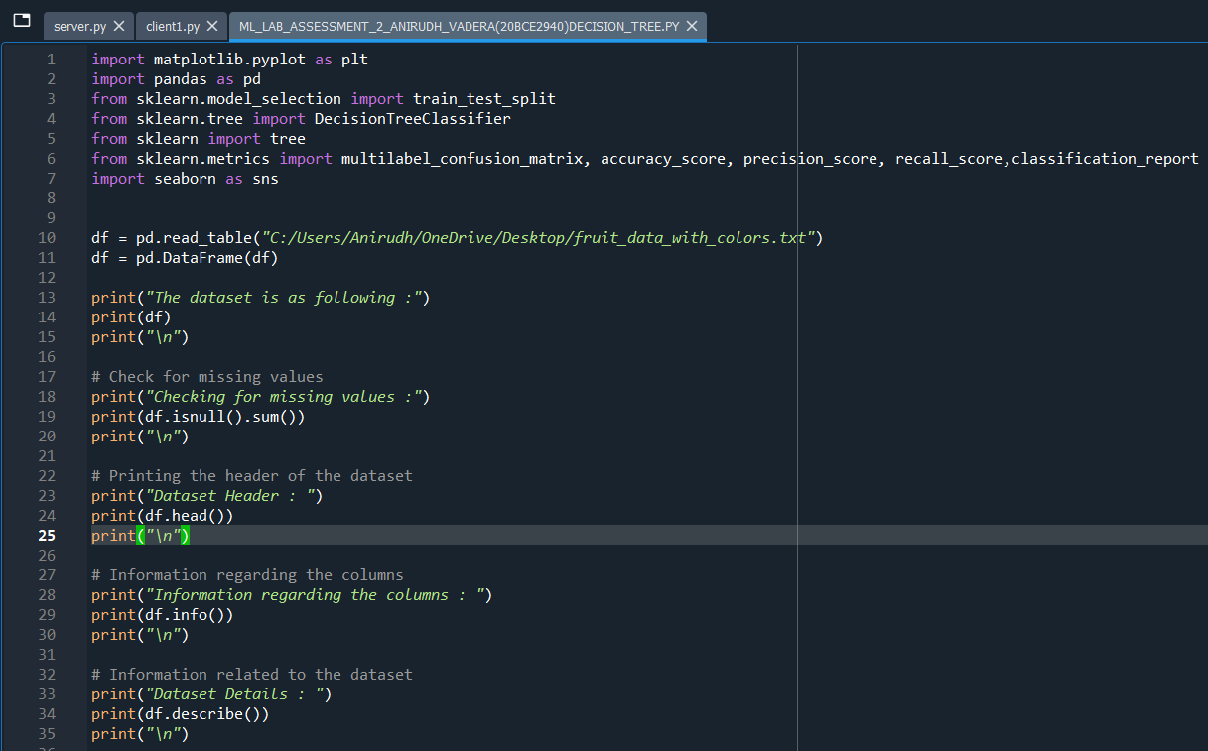

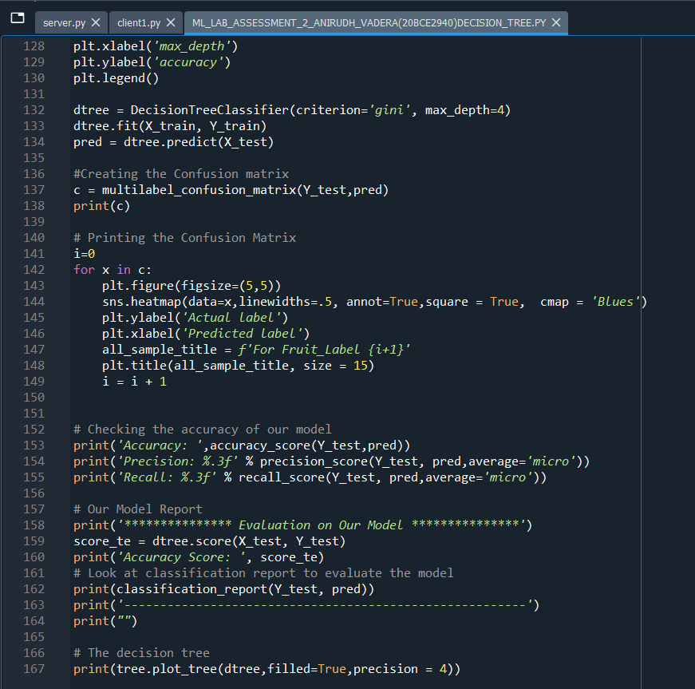

**Output and Results:**

**Dataset Details:**

**Dataset:**

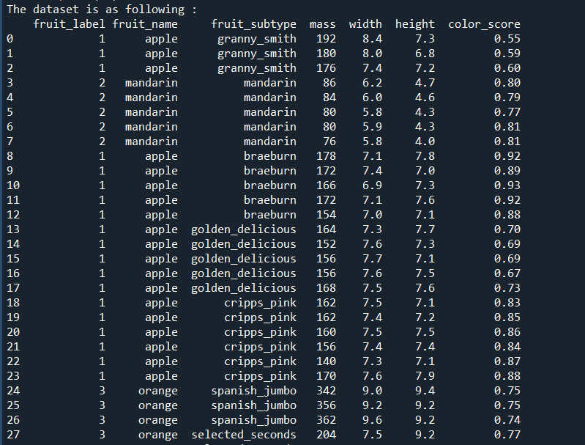

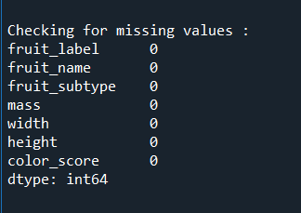

**As the missing values is none we can proceed further:**

**Dataset Details:**

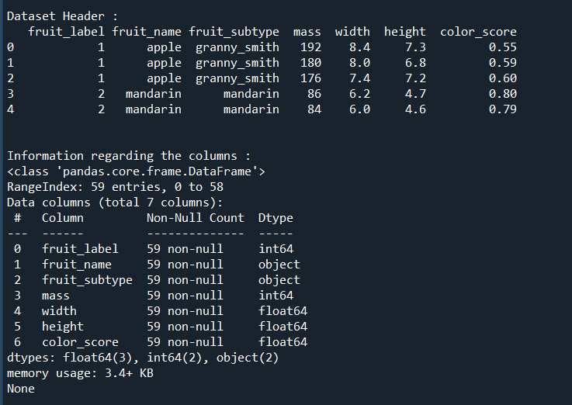

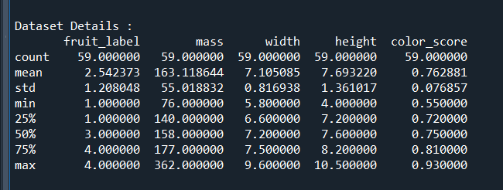

**Correlation Matrix:**

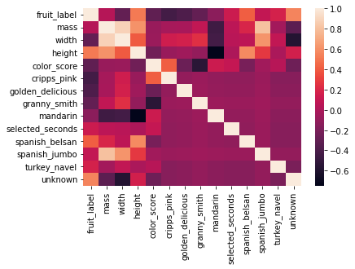

**We Infer Height has a great impact on predicting fruit_labels**

**Data Preparation**

**# Dummy Variables**

**# The variable fruit_subtype has many levels. We need to convert these levels into integer as well in order to predict**

**# For this, we will use something called dummy variables.**

**# Get the dummy variables for the feature 'fruit_subtype' and store it in a new variable - 'status'**

**# Now, you don't need all the columns.**

**# You can drop the fruit_subtype column, as the fruit_subtype can be identified with just the last 8 columns where encoding has already been done**

**# Drop 'fruit_subtype' as we have created the dummies for it**

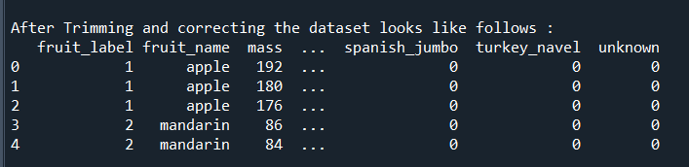

**Fitting the Decision Tree Model:**

**70% data for training and 30% for testing:**

**We use the gini criterion to train our model**

**Prediction Results:**

**The Predicted Y_Values And The Actual Y_Values are:**

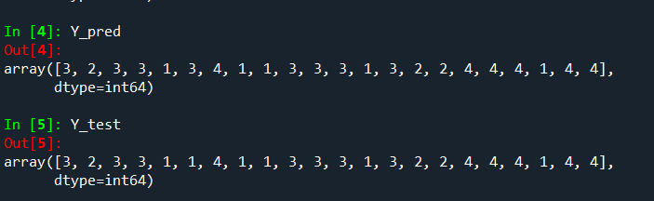

**Before Pruning:**

**Decision Tree Before Pruning:**

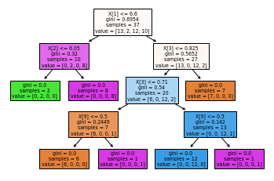

**Confusion Matrix:**

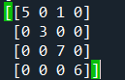

**For Individual Labels:**

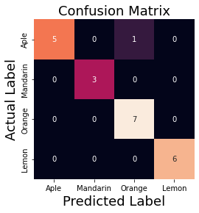

**Accuracy Analysis(Errors):**

**Checking the Accuracy of the model:**

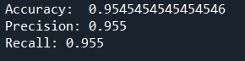

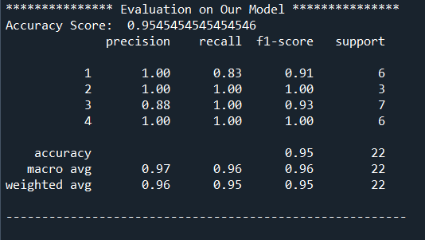

**Inference:**

**Label1 – Apple : Label2 – Mandarin : Label3 – Orange : Label4 - Lemon**

1. **From the correlation matrix we get to know that height has a great impact on predicting the fruit labels**
2. **The decision Tree has currently 13 nodes and a depth of 5**
3. **The confusion matrix tells us that there is no error in predicting the label 2, label 3 and label 4 while there is some error in predicting label 1. It classified a sing;le label 1 as label 3.**
4. **The accuracy of model without pruning is 95.45 percent which is quite good**
5. **The macro average recall is 96 percent and macro average precision is 97 percent which can be seen from evaluation**
6. **Individual scores are also given in evaluation**

**After Pruning:**

**First we check which type is better gini or entropy from below graph we get to know entropy and gini both give same performance at depth = 4**

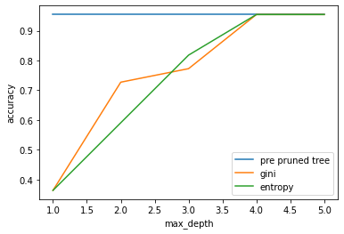

**Now all the points below the blue line (The pre pruned tree) is not required as it will prune the tree but the accuracy will decrease**

**So we chose depth 4 at which accuracy remains same for both pre and post pruned tree**

**This graph tells us that at depth = 4 the both methods works best for our case that means reducing the depth to 4 will give us same accuracy and also it will reduce the number of nodes in our decision tree and the max_depth will be equal to 4 instead of 5**

**No of Nodes Before Pruning: 13**

**No of Nodes After Pruning: 11**

**Decision Tree After Pruning:**

**Reduced Nodes:**

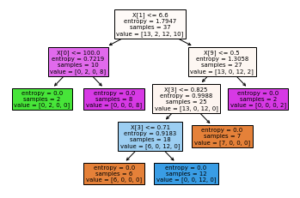

**Confusion Matrix:**



**For Individual Labels:**

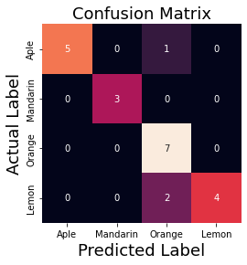

**Accuracy Analysis(Errors):**

**Checking the Accuracy of the model:**





**Inference:**

**Label1 – Apple : Label2 – Mandarin : Label3 – Orange : Label4 - Lemon**

1. **The decision Tree after pruning has 11 nodes and a depth of 4**
2. **The confusion matrix tells us that there is no error in predicting the label 2, label 3 and label 4 while there is some error in predicting label 1. It classified a single label 1 as label 3.**
3. **Accuracy without pruning and with pruning is same 95.45 percent which means our pruning is correct**
4. **Individual scores for precision and recall are also given in evaluation and are same as before**
5. **Therefore, we successfully have reduced the decision tree size without damaging the accuracy**